

NILE UNIVERSITY OF NIGERIA, JAHI

FACAULTY OF ENGINEERING

CPE 303

OBJECT ORIETED PROGRAMMING

1ST SEMESTER PROJECT

**TITLE OF PROJECT**

HOSPITAL MANAGEMENT SYSTEM

PROJECT ID: HMS02

**GROUP MEMBERS**

HANIF ADEDOTUN 191203007

ABDULLAI SANI 191203014

12TH DECEMBER, 2021

CLASS DIAGRAM

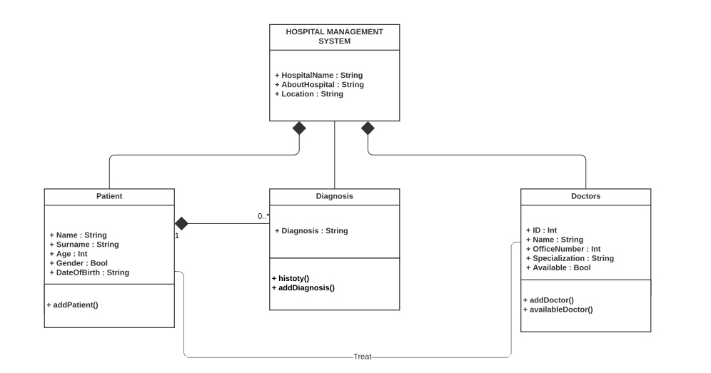

USE CASE DIAGRAM

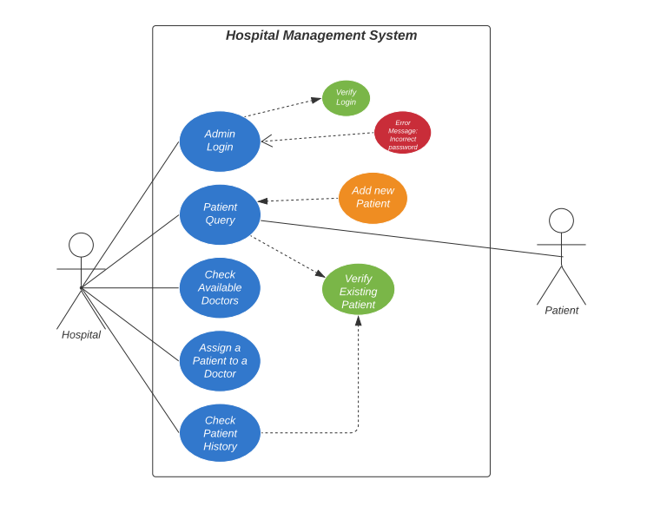

OBJECT DIAGRAM

